10.b)Use Flutter's debugging tools to identify and fix issues.
import 'package:flutter/material.dart';
import 'dart:developer' as developer;

void main() {
runApp(const MyApp());
}

class MyApp extends StatelessWidget {
const MyApp({super.key});

@override
Widget build(BuildContext context) {
developer.log('Building MyApp widget'); // Log message for debugging

return MaterialApp(
title: 'Flutter Debug Example',
home: Scaffold(
appBar: AppBar(title: const Text('Debugging Demo')),
body: const Center(child: DebugDemoWidget()),
),
);
}
}

class DebugDemoWidget extends StatefulWidget {
const DebugDemoWidget({super.key});

@override
State<DebugDemoWidget> createState() => _DebugDemoWidgetState();
}

class _DebugDemoWidgetState extends State<DebugDemoWidget> {
int _counter = 0;

void _incrementCounter() {
developer.log('Increment button pressed. Current counter: $_counter');

setState(() {
_counter++;
});

// Conditional breakpoint example: log if counter hits certain value
if (_counter == 3) {
developer.debugger(); // Will pause execution if a debugger is attached
developer.log('Counter reached 3 - breakpoint hit!');
}
}

@override
Widget build(BuildContext context) {
developer.log('Building DebugDemoWidget with counter=$_counter');

return Column(
mainAxisAlignment: MainAxisAlignment.center,
children: [
Text('You pressed the button this many times:'),
Text('$_counter', style: Theme.of(context).textTheme.headlineMedium),
ElevatedButton(
onPressed: _incrementCounter,
child: const Text('Increment Counter'),
),
],
);
}
}

Output:
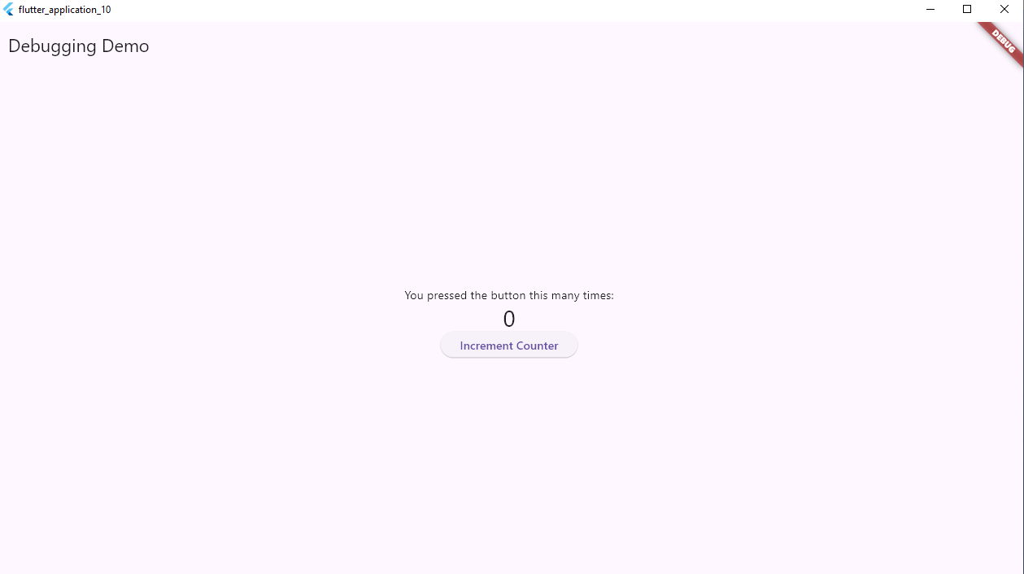
By pressing the button increment counter the value increases to 1 which as shown below
